Current Hyperparameter

Epoch: 25

Dropout rate: 0.2

Batch size: 32



Epoch Testing

15:

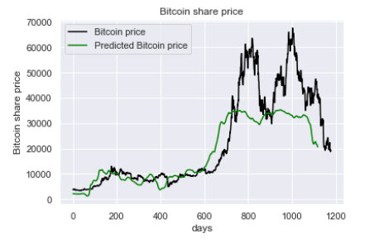

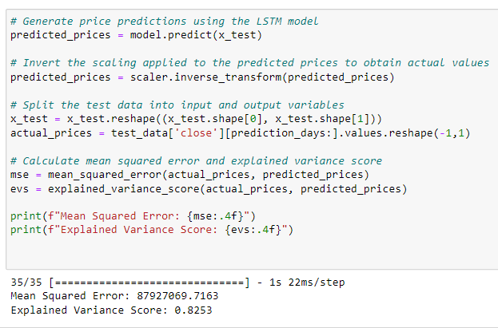

35:

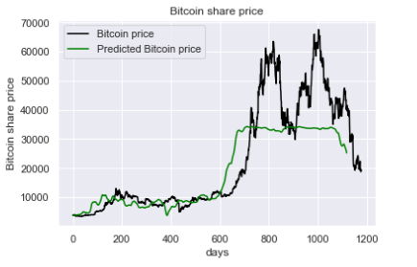

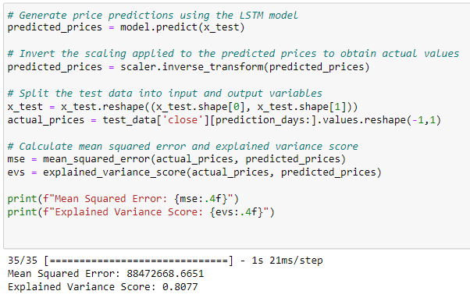

Dropout rate

0.1:

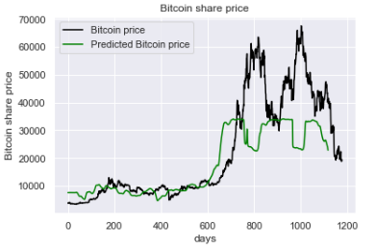



0.3:

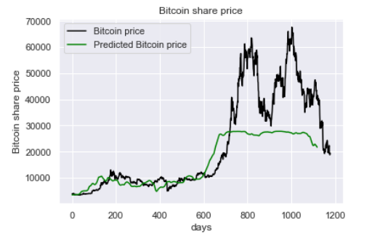

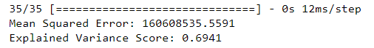

Batch size:

24:

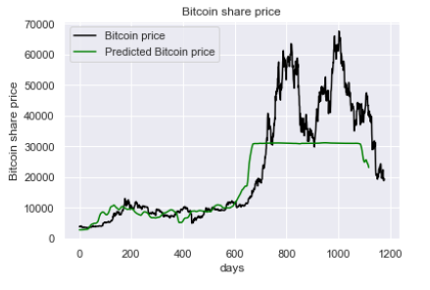

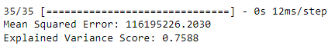

40:

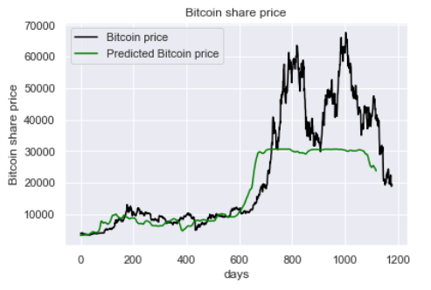

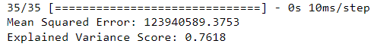

Conclusion: among the 3 hyperparameter, a change in dropout rate caused the greatest change in mean squared error and R^2 while the change in number of epochs caused the least change but this does not imply that dropout rate is the most important hyperparameter. Rather, this shows that the dropout rate is the most volatile hyperparameter. For the epoch, although higher is generally more accurate, having a bigger epoch means longer time for the model to run and an epoch of 35 usually stops at around 20-30 epochs for a patience value of 10 which means that the model usually stops improving after 10-20 epochs hence we decided to use an epoch of 25. As for the batch size, it is clear that having a batch size of 32 is optimal as compared to the other two comparisons. Overall, all 3 hyperparameters are important and have their own separate uses to improve the model.